6.Transfer of files from one Virtual Machine to another
Aim:
To transfer files from Ubuntu VM to Kali VM using NFS share, enabling read and write access on both ends.

STEPS:
METHOD 2 SHARED FOLDER
Step 1: Create a Shared Folder on Your Host

- On your host machine (Windows/Linux):

  - Create a folder, e.g., C:\VMShared

  - Add a test file (22IT043.txt) to confirm later.
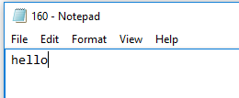

Step 2: Enable Shared Folder in VirtualBox (for Both VMs) Repeat this for both Ubuntu VMs.
- Shut down the VM if it’s running.

- In VirtualBox Manager, select your VM.

- Click Settings → Go to Shared Folders tab.

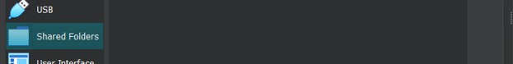

- Click “+” (Add new shared folder).
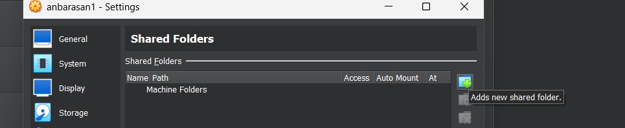

- Set:

  - Folder Path: Select C:\VMShared (or wherever you created it).

  - Folder Name: VMShared (updates once path is entered)

  - Check(Tick) Auto-mount
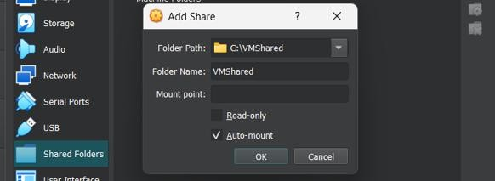

Click OK.

- Then, again Click OK (at bottom) to save.

Do this for both VMs VM2:
- InVirtualBox menu (inside VM window), go to:Devices → Insert Guest Additions CD image

VM1:

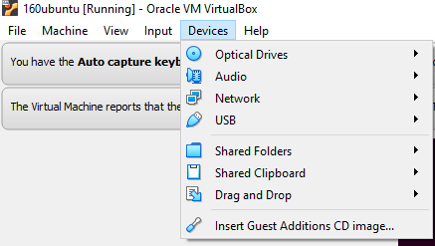

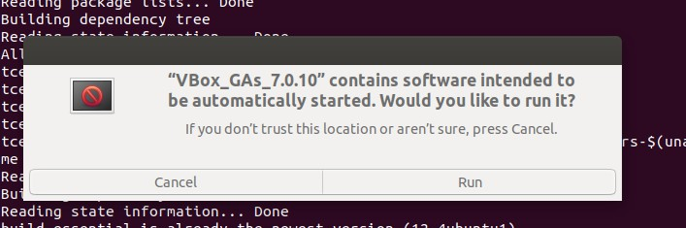

Now use the command: ls /media
  - It lists all the directories (i.e., mounted devices or drives) under the
/media directory.
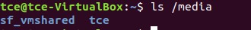

Therefore, in VM1 sf_VMShared folder is there in /media directory.

VM2: SAME PROCEDURE FOR virtualbox 2 Run the command: ls /media

Therefore, in VM2 also sf_VMShared folder is there in /media directory.

Step 4: Access the Shared Folder

After rebooting each VM, the shared folder should be mounted automatically at:
/media/sf_VMShared

To check, run the command :ls /media VM1 :
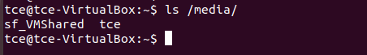

VM2 :

Run the command :ls /media/sf_VMShared VM1 :

VM2 :
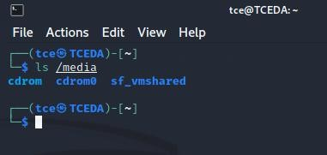

You should see the 22IT160.txt file from your host.

But in VM1 and VM2 , it asks for permission to list the files of sf_VMShared folder.

Step 5: Fix Permissions (if Permission Denied)

You need to add your user to the vboxsf group:

sudousermod -aGvboxsf $USER

Then reboot again:

sudo reboot

Now try again:

ls /media/sf_VMShared``
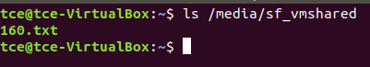
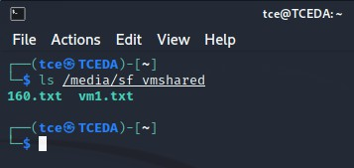

You should now have full access. Step 6: Transfer Files Between VMs
- Trying to print the content of 22IT043.txt file from VM1
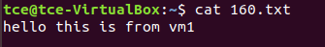

- Now in VM1, copy a file to /media/sf_VMShared folder,

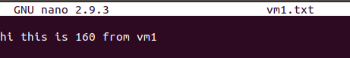

cp VM1.txt /media/sf_VMShared/

- Switch to VM2, and check the shared folder:

ls /media/sf_VMShared

The VM1.txt file will appear — you can copy it out to any other location and also you can edit files in shared folder location itself. Any changes done in shared folder using one VM will also be reflected to the other VM.
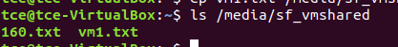
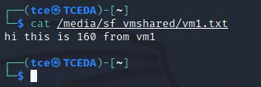

Also 22IT160.txt file is accessible in VM2,
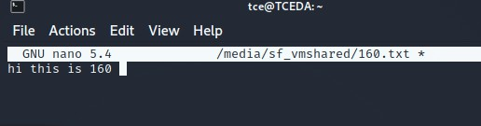

RESULT:

Thus the file transfer between Ubuntu and Kali VMs is executed successfully and both VMs can read and write files in the shared folder seamlessly.

